**Case – Power BI (25 Points)**

For this case, only utilize the Power BI software. Its going to be tempting to use Excel, but please fight that temptation. This exercise is to practice your skills in Power BI including importing and joining tables, using the formula options, creating visualizations and decomposition trees. Your submission will be to fill out this Word document and submit it on Microsoft Teams.

Your company distributes liquor to Bars across the United States. They have asked you to analyze and visualize their sales transactions by various attributes. Your manager has a few specific questions they would like you to address as follows (Note your first steps will be to import the tables from the Excel file “Case – Power BI”, join them, then add a revenue formula):

1. Which Customer (Name) had the highest sales? What was the amount?

The Greebrier Lobby Bar. $37614

1. Which Customer (Name) had the lowest sales? What was the amount?

Le Sirenguse Champagne Bar. $8627

1. Screenshot and paste below a visualization that supports your answers to questions 1 and 2:

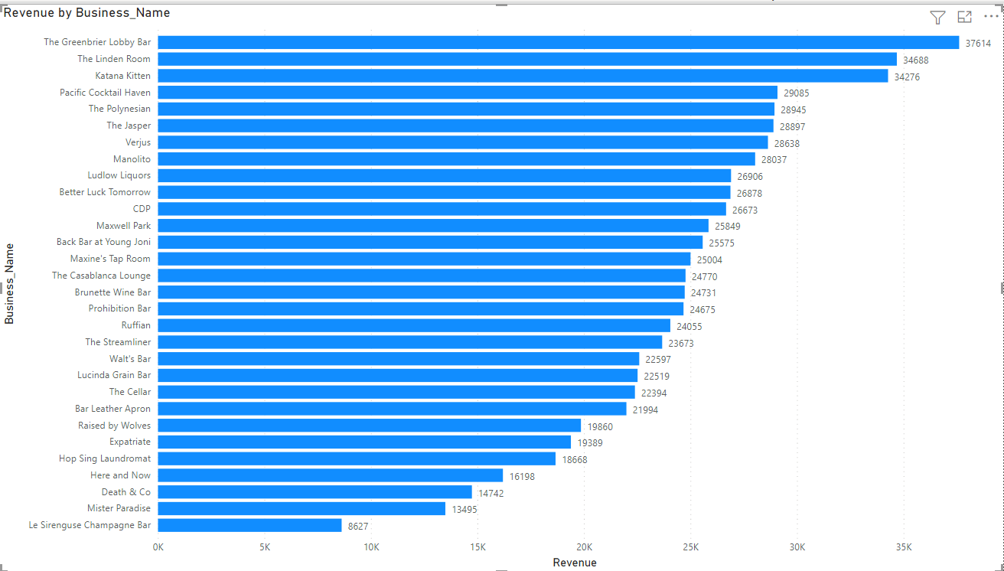

1. Which state had the highest sales of Vodka? What was the amount?

New York. $17880

1. Which city in the state you answered for question 4 had the had the lowest sales of Vodka? What was the amount?

Kingston. $4170

1. Screenshot and paste below a visualization that supports your answer to question 5:

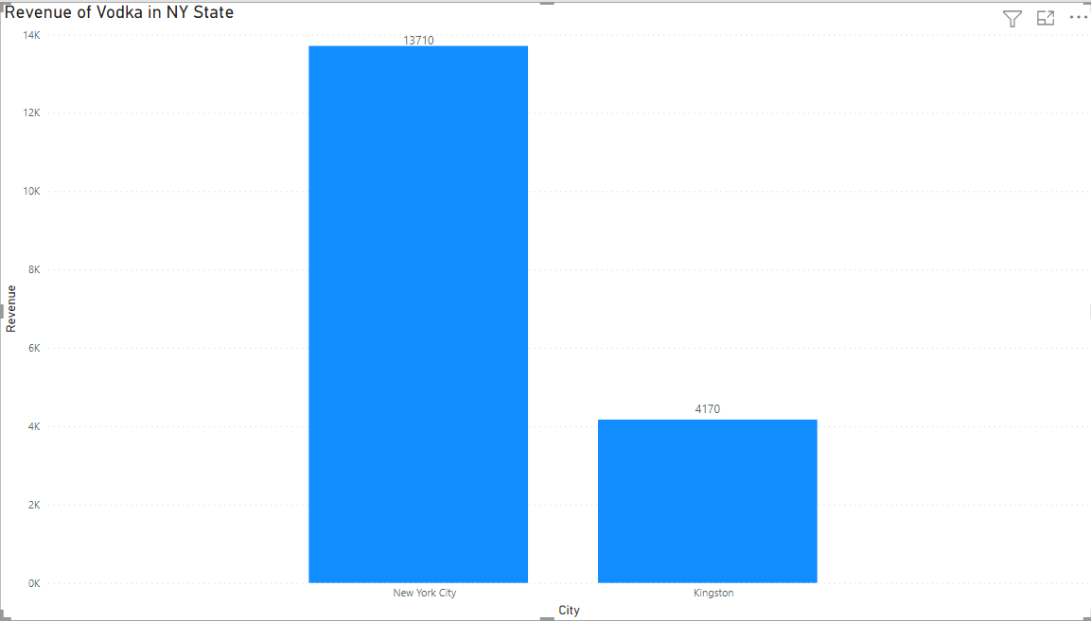

1. Create a decomposition tree that breaks down revenue in the following decomposition order:  
   By Base 🡺 By Descriptions 🡺 by State 🡺 by City

Paste a screenshot of your decomposition tree showing the following specific decomposition:

Scotch 🡺 Scotch Blended 2-Year 🡺 California 🡺 San Diego (note other cities will show as well)

